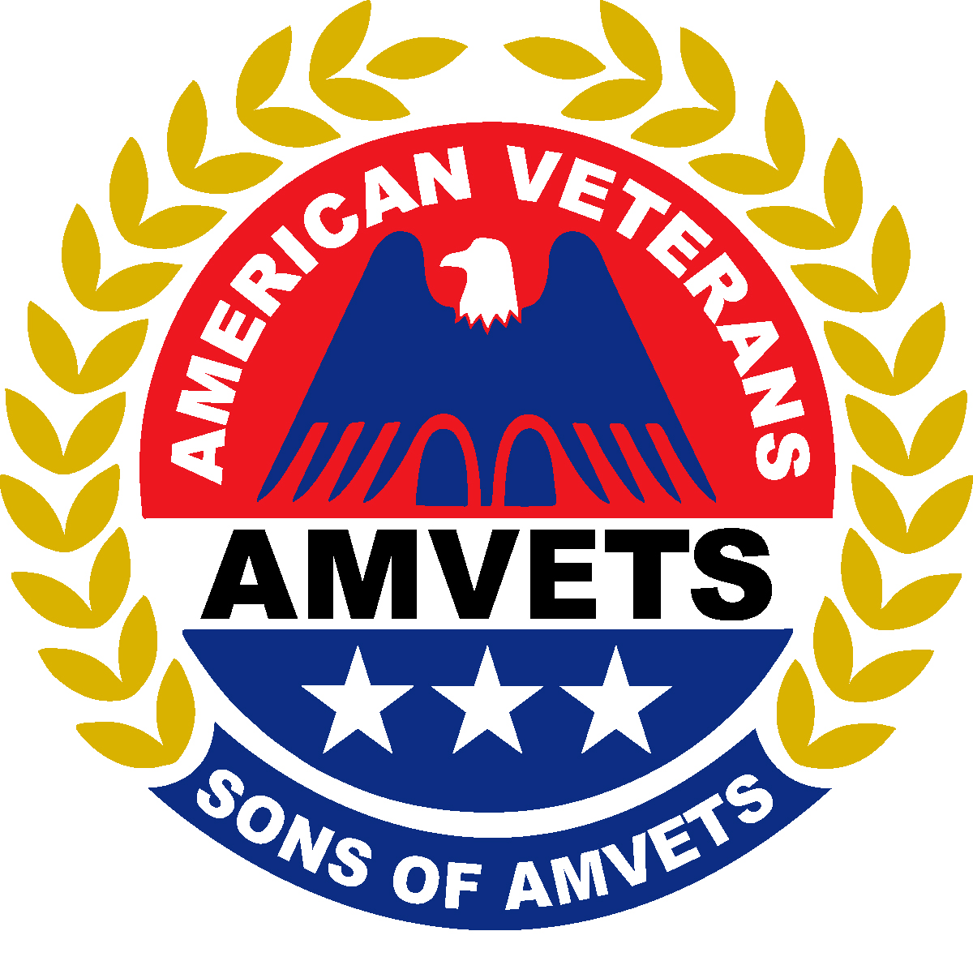
National Sons of AMVETS
Veterans Lodging Program Application Guidelines
Veterans Day or Spring NEC

This program is designed to encourage veterans to participate with the Sons of AMVETS on our Veterans Day visitation or during the Spring NEC Capital Hill effort. All applications will be considered on a first come, first considered basis. There are limited funds for this program so be prompt if you wish a veteran to participate. Also, keep in mind to consider the health and the probability that the veteran will in fact attend the event applied for. Due to the rigors of the activities on these trips, be sure the veteran can handle them health wise.

- Applications must be submitted by January 15th for Spring NEC and November 1st for Veterans Day to National Headquarters – 4647 Forbes Blvd., Lanham, MD 20706.
- All travel arrangements must be made by the Sons sponsor.
- Upon approval of the application, lodging will be secured for the veteran, by the National Department. The sponsor must confirm the attendance of the veteran, (7) seven days prior to the departure for the event. All secured lodging will be cancelled if confirmation is not received.
- All expenses other than lodging will be the responsibility of the veteran or sponsor, without any reimbursement from the National Department.
- Any and all lodging expenses that the National Department incurs due to any no-shows after confirmation was received will be the responsibility of the sponsor. Failure to reimburse the National Department within (30) thirty working days from the end of the event will result in the membership suspension of the sponsoring Son until the incurred expenses have been repaid to the National Department.
- At least one verification for both the sponsor and the veteran listed on the application must be submitted with the application, or the application will be rejected.
- Due to the limitation of funds for this program, applications will be accepted for either Veterans Day, or the Spring NEC, but not both for the same veterans. In addition, a veteran will not be approved for travel in back to back years unless there is low interest in the program that year. The application will be on hold until the deadline, then the veteran will be notified of approval or denial. The concept is to get as many veterans to participate with the Sons at these events as possible, but not to support a select few veterans for these functions.
- All rooms secured as part of this program will be double occupancy. Veterans attending the program are expected to room with either their Sponsor or another Veteran. When filling out the form, please indicate if there is a preferred roommate.
- The sponsoring Son will receive a telephone call confirming the application has been approved or rejected, and will be followed up with a letter stating the same. If the application is approved, a proposed agenda stating the lodging dates and the event schedule will be forwarded to the sponsor.

The contact person for application status and to verify confirmation of the event that sponsor applied for is:

Contact Person: Doug Brown / Legislative Director

Contact Person’s Phone: 440 – 752 – 5196

Contact Person’s Email: dbrown80@yahoo.com

Address: 7040 West River Rd.

Vermillion, Ohio 44089

Secondary Contact Person: Narcy Moran / Administrative Assistant

Secondary Contact Person’s Phone: (301) 683-4099

Secondary Contact Person’s Email: natsons@sonsofamvets.org

Tertiary Contact Person: Daniel K. Briggs / Finance Officer

Tertiary Contact Person’s Phone: 419– 563 – 4756

Tertiary Contact Person’s Email: dbriggs@att.net

Please retain these application guidelines.

National Sons of AMVETS
Veteran’s Day or Spring NEC
Veterans Lodging Application

Veteran’s Name
Branch of Service
Service Dates
Verification – (copy of DD214, Discharge, VA Card, or current Membership Card of a Veterans organization must be attached to the application.)
Post Affiliation (if any)
Veteran’s Signature
Sons Sponsor Name
Sons Sponsor Phone No. Home |  |  |  |  |  |  |  |  |  | Cell
Sons Sponsor Address (Print legibility)
Email Address
Squadron Affiliation
Department Affiliation
Verification – (Copy of Membership Card must be attached.)
Application For: (Check One) Veteran’s Day |  |  |  |  |  |  |  |  |  |  |  | Spring NEC
Name of preferred roommate |  |  |  |  |  |  |  |  |  |  | FORMCHECKBOX |  | No preference, please assign me a roommate
Sons Sponsor Signature

